Hello everyone! My name is Henry Yung Siu Hang. Today I would like to talk about People I Admire— Mao Zedong.

Mao Zedong was born on 12-26-1893. He was unlucky because he came from a farmer family. He lived with his mum, one brother and his dad.

He was born in Hunan Sheng and his mother died on 10-5-1919. He accepted basic education at Shaoshan when he was eight years old. He studied at Hunan First Normal University and set up communist party.

He is good at communication and outgoing. He is as brave as a lion because he led the army to fight the Chinese Nationalist party. Then, he is hard-working like a bee because he wrote a lot of books about politics.

Finally, I think Mao Zedong is great because he has a lot of talent and skills.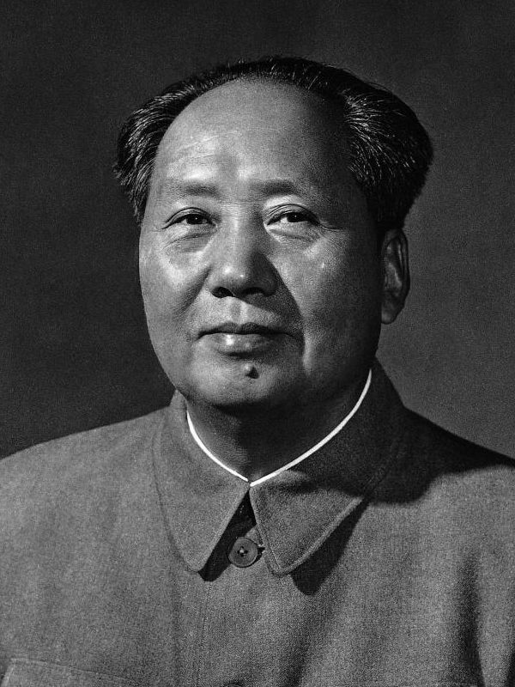

(143 words)