**A Visit to the Palace Museum**

Hello！My name is Lola. My class is 3B.Today, I would like to talk about my visit to the Palace Museum. I go there by car with my family.

The Palace Museum is in West Kowloon.There is grass in front of and behind the museum.We can run on the grass.

There are many exhibitions in the museum.There are seven galleries.We can see many antiques.Some of them are from the Forbidden City.The galleries are next to each other.

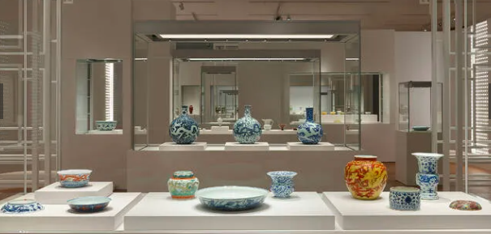 I enjoy the visit because it is interesting.