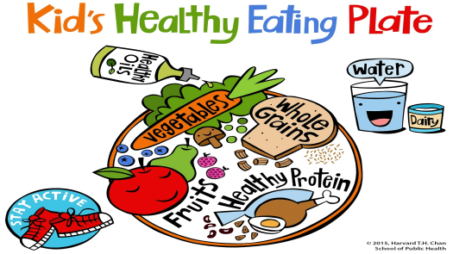

My Healthy Lunch

|  |
| --- |
| Hello, I am Shawn. I have dinner every day.          For dinner, I have some bread. It belongs to the grains group. I have cucumber and lettuce. They belong to the vegetables group. I have some oranges too. They belong to the fruits group. I also have chicken and fish. They belong to the protein group.           I also drink a glass of milk. It belongs to the dairy group.           I like my healthy lunch. |