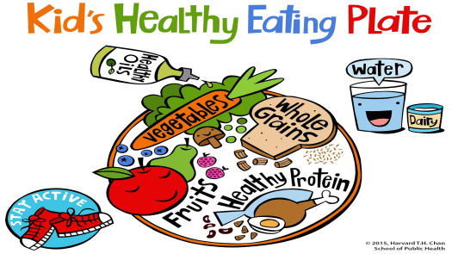

My Healthy Lunch

| Hello, I am Semyon. I have lunch every day.          For lunch, I have some noodles. They belong to the grains group. I have cucumbers and carrots. They belong to the vegetables group. I have some melons too. They belong to the fruits group. I also have chicken drumsticks. They belong to the protein group.           I also have some ice cream. It belongs to the dairy group.           I like my healthy lunch. |
| --- |