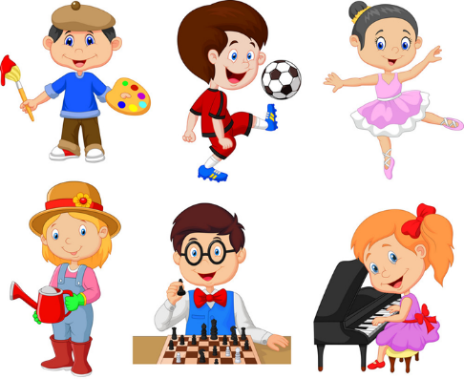

|  |
| --- |
| **Our Hobbies**  Hello, my name is Simon. I am good at drawing.       I can draw trees and animals. I draw pictures on Sundays. I like drawing country parks. It is fun to colour my pictures too.          Jason is my best friend. He is good at music. He can play the guitar but he can’t play the drum. He plays the guitar on Tuesdays. He likes playing in the band.            We enjoy our hobbies! |