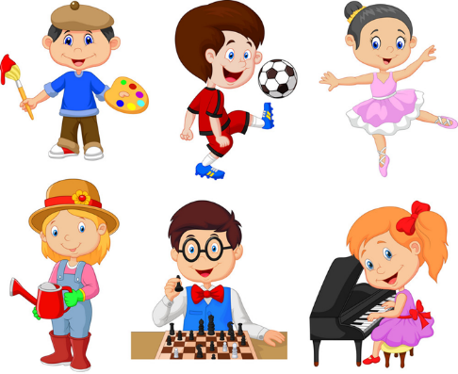

| **Our Hobbies**  Hello, my name is Hades. I am good at sports.       I can play football and basketball. I play football on Saturdays. I like playing ball games. It is fun to shoot the balls.          Jason is my best friend. He is good at music. He can play the guitar but he can’t play the drum. He plays the guitar on Tuesdays. He likes playing in the band.            We enjoy our hobbies! |
| --- |