**The Story of the Rainbow**

Once upon a time, all the colours in the world started to quarrel.

How are you?

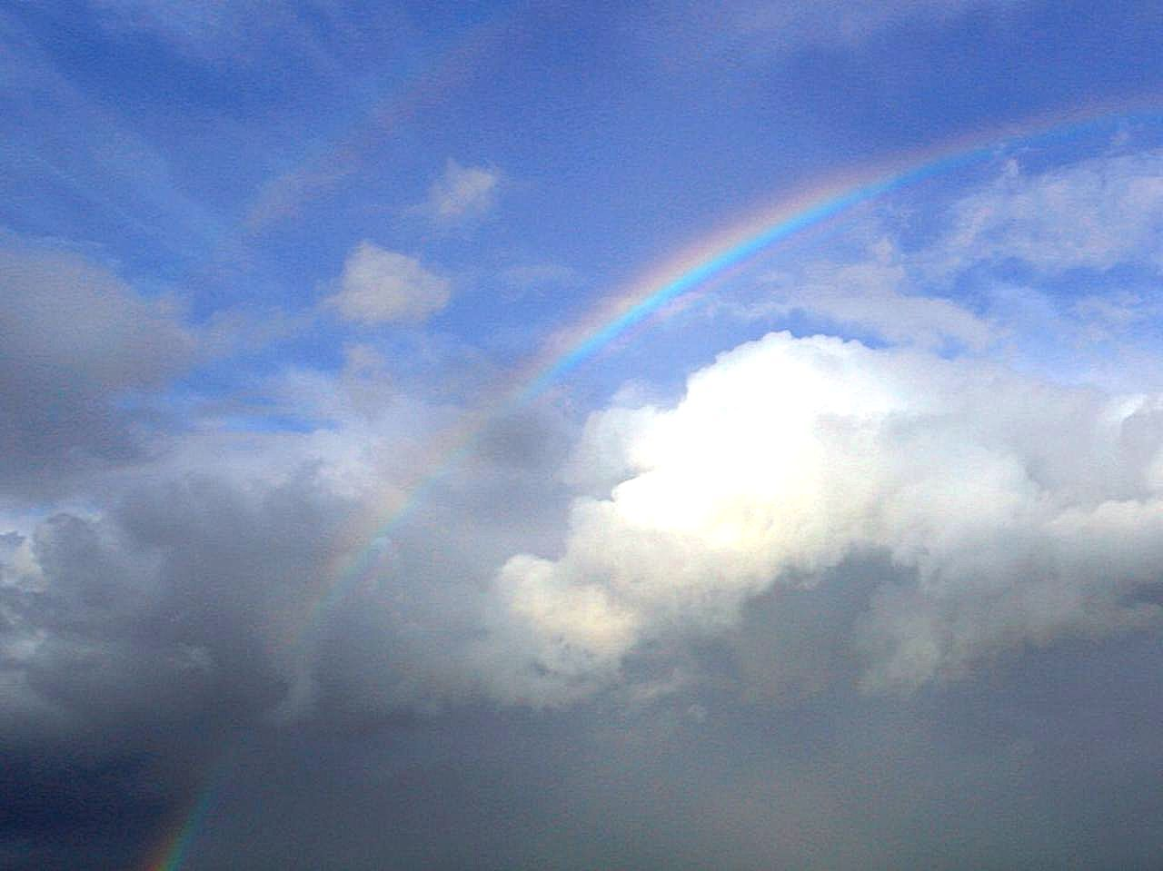

25-11-2019

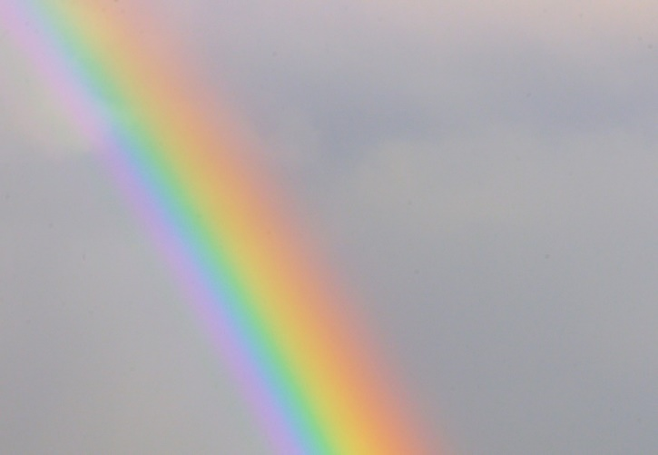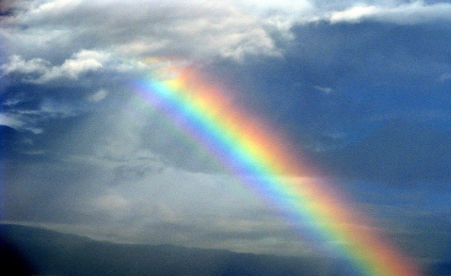

2-12-2019

YOT 2019